Press release

Neukirchen-Vluyn, September 13, 2018

Reliable hot runner cleaning from SCHWING Technologies
Gentle thermal removal of glass fiber reinforced polyamide, also for large and heavily overmolded components in the automotive industry
Today, hot runner technology allows injection molding of very complex and large body parts in the automobile supply industry. The industry often uses glass fiber reinforced polyamide components made of PA6 and PA12 to obtain satisfactory properties such as lightness, stability, and durability. The market for these products is growing tremendously. This growth is mainly due to the increasing demand for the glass fiber reinforced polymer owing to its special properties.
Thermally remove glass fiber reinforced polyamide
Glass fiber reinforced polyamide, however, presents a great challenge in all hot runner systems: Contamination and blockages are often predestined and, unfortunately, machine downtimes are the order of the day. “Something that can be avoided”, emphasizes Virgilio Perez Guembe, Sales Manager of SCHWING Technologies. His company specializes in thermal cleaning and offers a fast, residue-free and reliable solution for large hot runner systems. “Our user-friendly pyrolysis system, MAXICLEAN, also cleans overmolded hot runner distributors with complicated geometries and glass fiber components, reliably, safely and gently, without leaving any polymer residues, carbon remnants, or inorganic contaminants.” Some of the unrivalled advantages for manufacturers in the automotive industry include the ability to clean inside pores and the significantly prolonged service life of the equipment. Cleaning is flexible, safe, effective, and environmentally friendly.
MAXICLEAN pyrolysis system for large hot runner systems
Cleaning of the often very complex hot runner distributors is usually a great challenge for many users of injection molding plants. “With the very long, internal flow channels in particular, manual cleaning proves impossible,” explains Perez Guembe, pointing out that even the use of cleaning granules usually yields poor results. The expert therefore recommends thermal cleaning for large hot runner systems: In a single process step that lasts four to eight hours, MAXICLEAN completely removes all polymer residues without impacting the tools mechanically or thermally, Perez Guembe confirms. “The precisely controllable cleaning process takes place in an external gas-heated cleaning chamber with special hot air routing for optimal distribution of the temperature. The automatic process control monitors the development of low temperature carbonization gases and ensures short cleaning times. Inorganic residues are removed using an appropriate posttreatment method.” MAXICLEAN works without waste water and has a separate afterburner which completely burns the carbonization gases above 800 °C and discharges them via the chimney. The MAXICLEAN system from SCHWING comes with a loading trolley, an exhaust chimney and, if desired, a hydrolysis unit for cleaning the filter.
Hot runner cleaning as a service
SCHWING also offers hot runner cleaning services at its premises in Lower Rhine Neukirchen-Vluyn for the automotive industry and its suppliers. “Just in Time, we offer complete cleaning of over-sprayed hot runner distributors, including pick-up and return transport, within a radius of around 300 kilometers”, adds Virgilio Perez Guembe. This benefits many renowned car automobile manufacturers and global market leaders dealing in, for example, car body parts or modules. SCHWING cleans hot runners within a very short time, which allows the production of front-end modules, composite parts, bumpers, tailgates, cockpit modules, accelerator pedals, etc. to continue without prolonged downtimes.
Further Information: https://www.thermal-cleaning.com/en/cleaning-systems-and-accessories/pyrolysis-furnaces.html

SCHWING Technologies
SCHWING Technologies has been operating since 1969 and is the worldwide technological leader for high-temperature systems for thermal cleaning, thermo-chemical finishing and heat treatment of metal parts and tools. The owner-managed company constructs, manufactures and operates its systems at its headquarters in Neukirchen-Vluyn in Germany's Lower Rhine region. Built upon the achievements of German engineering, the medium-sized business is globally the best-known specialist in the removal of plastics. Among its around 2,500 international clients are companies from the plastics and fiber industries, as well as from the chemicals and automobile sectors. With its 80-strong personnel, the company is equipped with the tools and systems for any cleaning need and delivers the best economy, ecology and quality. SCHWING is also a reliable service partner for contract cleaning by cleaning more than 250,000 tools and parts each year to the highest environmental and qualitative standards. In the words of Ewald and Thomas Schwing, the two managing directors at SCHWING Technologies GmbH, “So far, there has not been a single component that we have not been able to free from polymers and inorganic contaminants.”

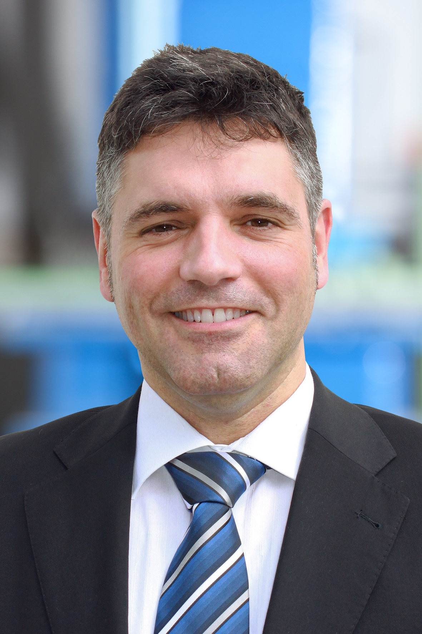
Virgilio Perez Guembe, Sales Manager of SCHWING Technologies
Photo credit: SCHWING Technologies
Photo download: https://drive.google.com/file/d/1JCaBP1Yt0lN2UcCbhq3V8Ezu54sRTeOQ/view?usp=sharing
MAXICLEAN thermal cleaning system from SCHWING Technologies for large hot runner systems
Photo credit: SCHWING Technologies
Photo download: https://drive.google.com/file/d/1wuAfsOeVgixIqQkSIZl6Su1Jd2tz2YYZ/view
Cleaning chamber of the MAXICLEAN thermal cleaning system from SCHWING Technologies
Photo credit: SCHWING Technologies
Photo download: https://drive.google.com/file/d/1US4qvAuRffIHt5ZiFjVA5H7Bf297CzvC/view?usp=sharing

Hot runner before cleaning
Photo credit: SCHWING Technologies
Photo download: https://drive.google.com/file/d/10M7NaGYMMJxrZhnOiQxB_AZo08Nd1hLj/view?usp=sharing

Hot runner after cleaning
Photo credit: SCHWING Technologies
Photo download: https://drive.google.com/file/d/1p6i2Tzx211s8vIGr-bRxSTFWu9qG4oF-/view?usp=sharing

Press contact
Nicola Leffelsend
SCHWING Technologies GmbH
Oderstraße 7
47506 Neukirchen-Vluyn
T +49 2845 930 146
redaktion@schwing-tech.com
www.schwing-technologies.de

