Press release

Neukirchen-Vluyn (Germany), July 24, 2019

NEW: SCHWING Technologies with VACUCLEAN COMPACT at K 2019
Compact vacuum pyrolysis system cleans small tools and machine parts

Every three years, the entire plastic production community meets in Düsseldorf. Exhibitors and visitors come to the famous K in the Rhine metropolis in October 2019. While many will travel from far and wide, exhibitor SCHWING Technologies (Hall 9 at Booth A77) will be on hand for a clear home game. The thermal cleaning expert has its headquarters in Neukirchen-Vlyun on the Lower Rhine, only 30 kilometers away. The specialist for plastic removal has presented at K since 1979, celebrates its 50th anniversary in 2019 and looks forward to the upcoming international exchange from 16 to 23 October 2019.

New: compact vacuum pyrolysis plant
The SCHWING engineers will bring their brand new, fully automatic VACUCLEAN COMPACT with them for display: a lightweight, small-format vacuum pyrolysis system with a straightforward design and clean lines. “One hundred percent made in Germany,” emphasizes Thomas Schwing, Managing Director of SCHWING Technologies, and is visibly proud of the new system. The system is particularly suitable for the thermal removal of plastics from smaller parts, with a maximum load of 50 kilograms. But Thomas Schwing knows: “This is precisely what many of our customers appreciate who, in addition to laser filters, regularly clean screw elements, spinnerets, spin packs, pelletizing discs or screen changers, for example.”

Lightweight and small format system
The system with its steel and aluminium body weighs around 750 kilograms. “With overall dimensions of 210 cm by 120 cm by 100 cm (H x W x D), it is only slightly larger than a classic American refrigerator,” describes Managing Director Alfred Schillert, who was in charge of product development. He and his development team, headed by Axel Sokol, have integrated all essential components into the interior of the system to save space. This includes the catalytic converter, vacuum pump, control cabinet and fittings as well as a cleaning chamber of 50 cm by 50 cm by 30 cm (H x W x D), including loading platform. “Controls are easy to operate using a 5.7-inch touchscreen integrated into the housing,” says Schillert, pointing out that customers also always have a good view of status with the external tower light, even from a distance.

Thermal cleaning: energy-efficient and environmentally friendly
Like all SCHWING systems, the VACUCLEAN COMPACT is extremely energy-efficient and environmentally friendly at the same time. “Internationally, this is an important selling point for us because low-emission and environmentally friendly systems are in demand not only in Europe and Asia, but also worldwide,” confirms Head of Sales Virgilio Perez Guembe. The fact that the system operates without gas fuel makes the system all the more attractive to the international public. For 50 years, the German equipment manufacturer has been a specialist for thermal cleaning systems. “Our plants reliably remove all plastic residues from production tools while protecting the material,” emphasizes Perez Guembe, referring to the proven expertise that pays off for all users: “The advantages for the plastic production industry are obvious: shorter machine downtimes and an increased service life of the cleaned parts not only save costs but also time.”

Demand for compact systems
With the new system, which can be easily installed, SCHWING's team of engineers is responding to the increased international demand for more compact systems in particular. Customers come primarily from the plastics recycling industry, compounding industry and masterbatch environment. Universitites, research institutions and laboratories will also benefit from the smaller, cheaper systems worldwide. With its international network, SCHWING Technologies advises and supports its customers all over the world. Since the beginning of 2019, American and Canadian customers have also benefited from the expertise of SCHWING North America Technologies, based in Princeton, New Jersey.

Keywords: K 2019, VACUCLEAN COMPACT, vacuum pyrolysis system, thermal cleaning, cleaning, plastic removal, tool cleaning, machine part cleaning, plastic recycling, compounding, masterbatch, laser filter, screw elements, spinneret, spin pack, pelletizing disc, screen changer

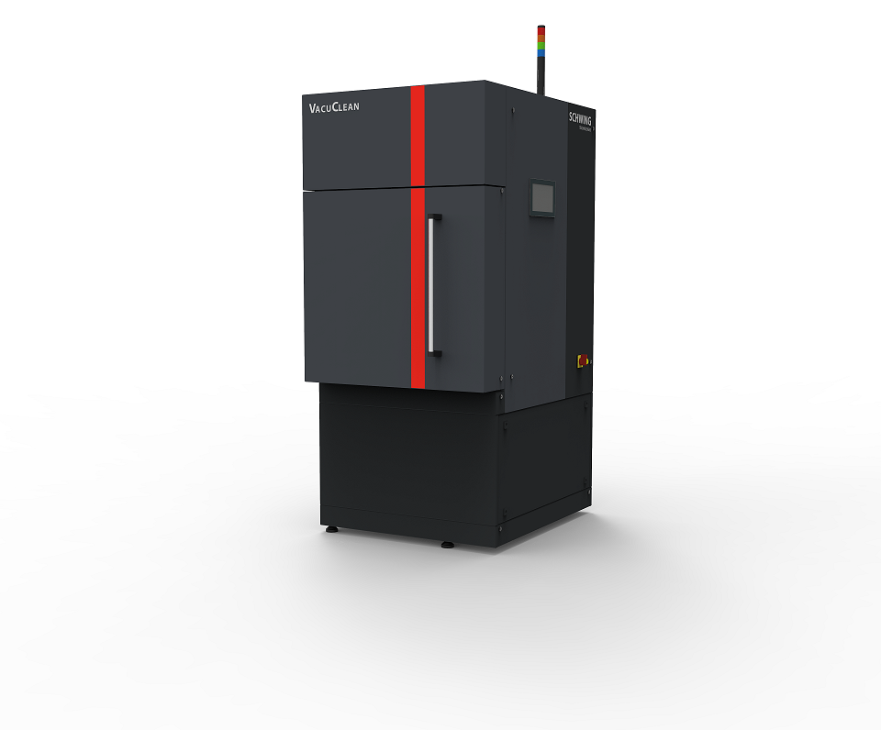
Photo: compact vacuumpyrolyse-system VACUCLEAN COMPACT from SCHWING Technologies
Photo credit: SCHWING Technologies
Download: https://drive.google.com/file/d/18ih1z4JAbSk9lFK6E-CcjG0qEZj9oJ2e/view?usp=sharing

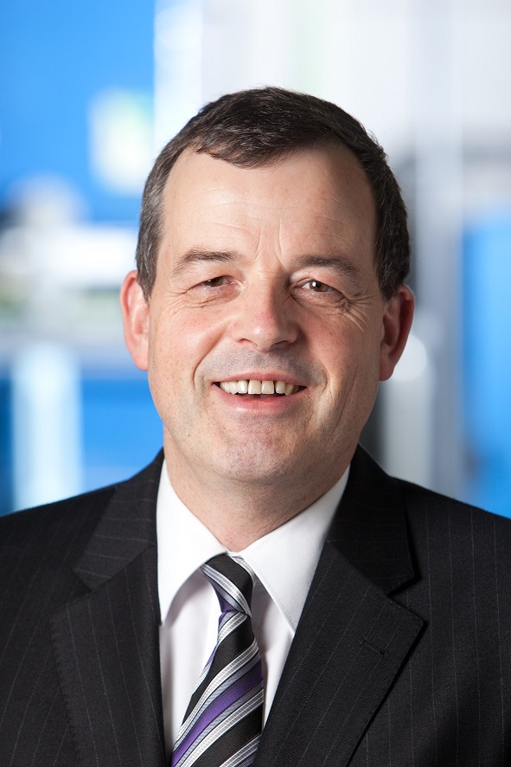
Photo: Thomas Schwing, Managing Director of SCHWING Technologies
Photo credit: SCHWING Technologies
Download: https://drive.google.com/file/d/1T-GmCrrzQgC0xZm9tDb5rfHf0-k3AixO/view?usp=sharing

Photo: Alfred Schillert, Managing Director of SCHWING Technologies
Photo credit: SCHWING Technologies
Download: https://drive.google.com/file/d/1DjMnkdI-LCCWnGmH8zTHzhVaouNgmv6Y/view?usp=sharing

Photo: Virgilio Perez Guembe, Head of Sales at SCHWING Technologies
Photo credit: SCHWING Technologies
Download: https://drive.google.com/file/d/15t27vmC8qopPIO1UsYECWk3lXo9wKLmu/view?usp=sharing

SCHWING Technologies
SCHWING Technologies has been operating for 50 years and is the worldwide technological leader for high-temperature systems for thermal cleaning, thermo-chemical finishing and heat treatment of metal parts and tools. The owner-managed company designs, manufactures, and operates systems at its headquarters in Neukirchen-Vluyn in Germany's Lower Rhine region. Built upon the achievements of German engineering, the medium-sized business is globally the best-known specialist in the removal of plastics. Among SCHWING’s approximate 2,500 international clients are companies from the plastics and fiber industries, as well as from the chemicals and automobile sectors. For every cleaning need, the company with its approximately 80 employees offers the most economically, ecologically and qualitatively best technology and cleaning solution. SCHWING is also a reliable service partner for contract cleaning by processing more than 250,000 tools and parts each year to the highest environmental and qualitative standards. So far, there has not been a single component that we have not been able to free from polymers and inorganic contaminants, confirm the three managing directors Ewald Schwing, Thomas Schwing and Alfred Schillert. Founded in 1969, the company celebrates its 50th anniversary in 2019 and opened SCHWING Technologies North America Inc., a new sales company in the USA, this year.

Press contact
Nicola Leffelsend
SCHWING Technologies GmbH
Oderstraße 7
47506 Neukirchen-Vluyn
Germany
T +49 2845 930 146
redaktion@schwing-tech.com
www.schwing-technologies.de

