Press release

Neukirchen-Vluyn (Germany), October 8, 2019

New at the trade fair: Thermal cleaning of filter candles up to 1.70 meters high
Vacuum pyrolysis system VACUCLEAN 0917 from SCHWING Technologies removes up to 150 liters of plastic in one application

At this year's K 2019 in Düsseldorf from October 16 to 23, SCHWING Technologies will be presenting its extended vacuum pyrolysis system VACUCLEAN 0917 for the first time (Hall 9/booth A77). With this system, the German expert for environmentally friendly and energy-efficient thermal cleaning systems is primarily targeting users of especially tall filter candles and bundles up to 170 cm high and 90 cm in diameter. The SCHWING system includes a very large melt-off container, holding up to 150 liters of plastic in one application. The new vacuum pyrolysis system gently removes all plastic residues from very fine filters and guarantees filter qualities for the highest production results. Materials such as BOPP, PET and PC can be removed.

Safe and gentle vacuum pyrolysis
The fully automatic cleaning process of the VACUCLEAN 0917 takes place in an electrically heated vacuum cleaning chamber. The temperature is measured directly on the filter bundle, which is first heated slowly and gently. Here, a large part of the adhering plastic melts off and flows out. At approximately 450 degrees Celsius, the decomposition of the remaining material takes place. Remaining carbon is finally removed by carefully adding air (controlled oxidation). A sophisticated sensor system controls the entire cleaning process, so excess temperatures do not occur at any time.

Worldwide sales and testing at company headquarters
SCHWING sells its plants and complete process solutions worldwide. In Germany, the company also provides cleaning services and invites its customers to test the cleaning processes at its headquarters in Neukirchen-Vluyn. In order to achieve optimum results, the company is constantly developing its equipment and adapting its cleaning processes to new material mixtures and metal filter designs.
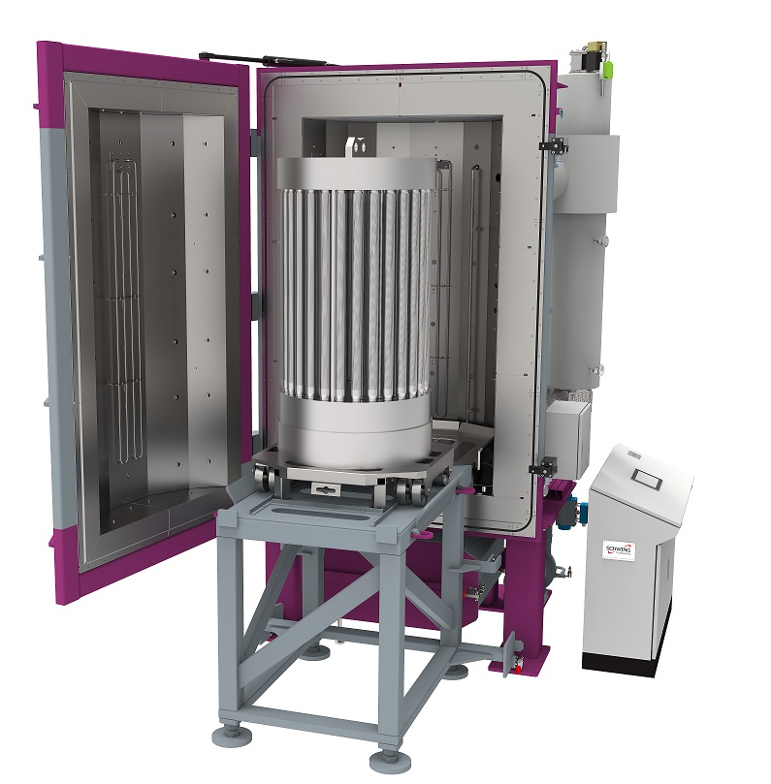
The particularly tall thermal vacuum pyrolysis system VACUCLEAN 0917 cleans filter candles with a height of up to 170 cm. The large melting container holds up to 150 liters of plastic in just one application
Photo Credit: SCHWING Technologies
Download: https://drive.google.com/file/d/10oG4en19HRdUquRLZ9OQSSMgLY_nAw4B/view?usp=sharing

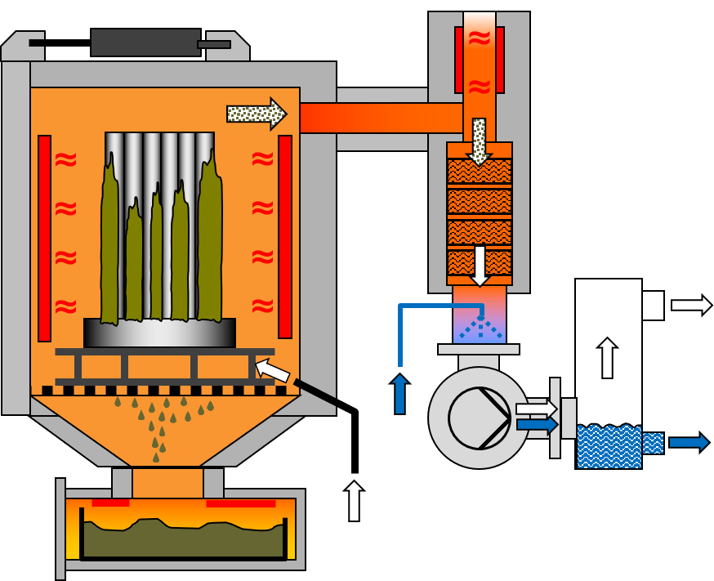
Functional principle of the VACUCLEAN thermal vacuum pyrolysis system from Schwing Technologies
Photo Credit: SCHWING Technologies
Download: https://drive.google.com/file/d/1tMh8ASzJBBteoa0DFUuduJE7mSwBzarM/view?usp=sharing

Keywords: Vacuum pyrolysis, vacuum cleaning, cleaning system, VACUCLEAN 0917, plastic removal, tall filter candles, tall filter bundles

SCHWING Technologies
SCHWING Technologies has been operating for 50 years and is the worldwide technological leader for high-temperature systems for thermal cleaning, thermo-chemical finishing and heat treatment of metal parts and tools. The owner-managed company designs, manufactures, and operates systems at its headquarters in Neukirchen-Vluyn in Germany's Lower Rhine region. Built upon the achievements of German engineering, the medium-sized business is globally the best-known specialist in the removal of plastics. Among SCHWING’s approximate 2,500 international clients are companies from the plastics and fiber industries, as well as from the chemicals and automobile sectors. For every cleaning need, the company with its approximately 80 employees offers the most economically, ecologically and qualitatively best technology and cleaning solution. SCHWING is also a reliable service partner for contract cleaning by processing more than 250,000 tools and parts each year to the highest environmental and qualitative standards. So far, there has not been a single component that we have not been able to free from polymers and inorganic contaminants, confirm the three managing directors Ewald Schwing, Thomas Schwing and Alfred Schillert. Founded in 1969, the company celebrates its 50th anniversary in 2019 and opened SCHWING Technologies North America Inc., a new sales company in the USA, this year.

Press contact:
Nicola Leffelsend
SCHWING Technologies GmbH
Oderstraße 7
47506 Neukirchen-Vluyn
Germany
T +49 2845 930 146
redaktion@schwing-tech.com
www.schwing-technologies.de

