Press release

Neukirchen-Vluyn (Germany), October 17, 2019

Green Cleaning: environmentally friendly cleaning solutions for laser filters in the recycling industry
SCHWING Technologies focuses on green technologies - for 50 years

Circular Economy is one of the top topics at this year's K 2019. Plastics and environmental protection, recovery and recycling are the buzzwords here. The recycling industry is showing how new materials can be obtained from using recycled waste materials, like high-quality polyethylene-based polymers (PE). Mainly light packaging waste is used: packaging plastics and commercial mixed films. Recyclable "waste" is a raw material source that works, provided the product quality is satisfactory. Fine laser filters are used in the industry to ensure precise filtration. They are essential in the production process for high-quality and sustainable recycling. Cleaning and reuse can reduce production costs, helping to protect the environment.

Gentle cleaning results through thermal plastic removal
In order to maintain the desired quality, regular cleaning processes are necessary. In around six hours, the MAXICLEAN thermal pyrolysis system from SCHWING Technologies removes all plastic residues at 450 degrees Celsius. This without mechanically or thermally impairing the laser filter and in just one operation. The cleaning process, which can be precisely controlled and reproduced at any time, takes place in an externally gas-heated cleaning chamber. A special hot air duct ensures that the temperature is distributed optimally and evenly.

The system also monitors the carbonization gas development and ensures a short cleaning time. Laser filters are then cleaned by a two-hour post-treatment with high-pressure water. They are then placed into an ultrasonic bath before being rinsed, dried and treated for corrosion.

Alternatively, SCHWING recommends a treatment of around nine hours in the VACUCLEAN vacuum pyrolysis system. The fully automatic cleaning process takes place in an electrically heated vacuum cleaning chamber. The System measures the temperature directly on the part to be cleaned, which is initially heated slowly and gently. Most of the adhering plastic melts off and flows out. The remaining plastic is then decomposed at around 440 to 450 degrees Celsius. Finally Carbon is removed by slowly adding air (controlled oxidation). A sophisticated sensor system controls this cleaning process, so excessive temperatures do not occur at any time. Here, too, inorganic residues can be easily removed during post-treatment (e.g. by compressed air).

Environmental protection since 1969
For 50 years, SCHWING Technologies has considered environmental protection as a top priority in the plastics industry with its environmentally friendly and energy-efficient systems for the thermal removal of plastics, such as laser filters. Since its foundation in 1969, environmental awareness and energy optimization have been a focus of the German equipment manufacturer's machinery and cleaning solutions. With its green technologies, the company is an internationally successful specialist for thermal cleaning. The expert offers reliable and cost-reducing systems, as well as sustainable and gentle solutions for all machine parts and tooling of various plastic production industries.

Keywords: laser filter, laser filter cleaning, thermal pyrolysis, thermal cleaning, MAXICLEAN, vacuum pyrolysis, vacuum pyrolysis system, VACUCLEAN, cleaning, plastic removal, tool cleaning, machine part cleaning
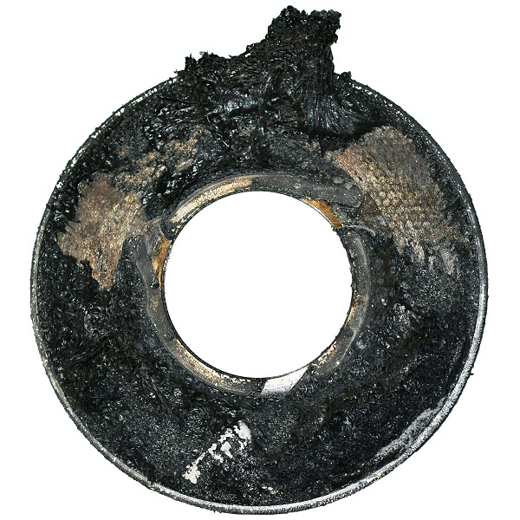
Fine laser filter before cleaning
Photo credit: SCHWING Technologies
Download: https://drive.google.com/file/d/16OC7oUUQusZ8SGCkDWzOGi0mPwKchCNx/view?usp=sharing

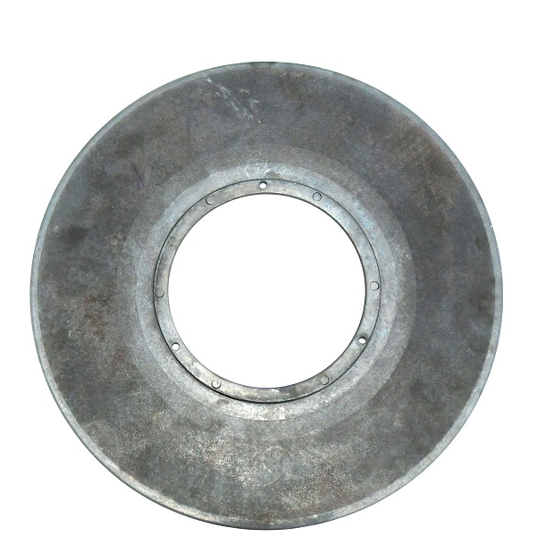
Fine laser filter after cleaning
Photo credit: SCHWING Technologies
Download: https://drive.google.com/file/d/1m54e86r8NaRPw0OYk7r4BdWC_r07WFdR/view?usp=sharing

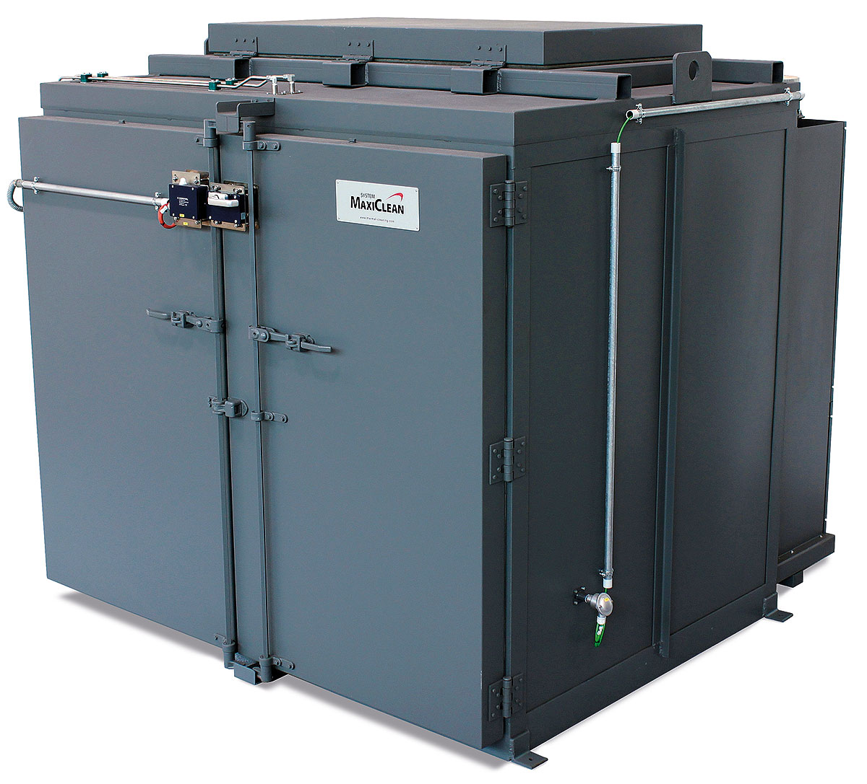
In around six hours, the MAXICLEAN thermal cleaning system from SCHWING Technologies removes all plastic residues at 450 degrees Celsius
Photo credit: SCHWING Technologies
Download: https://drive.google.com/file/d/1wuAfsOeVgixIqQkSIZl6Su1Jd2tz2YYZ/view?usp=sharing

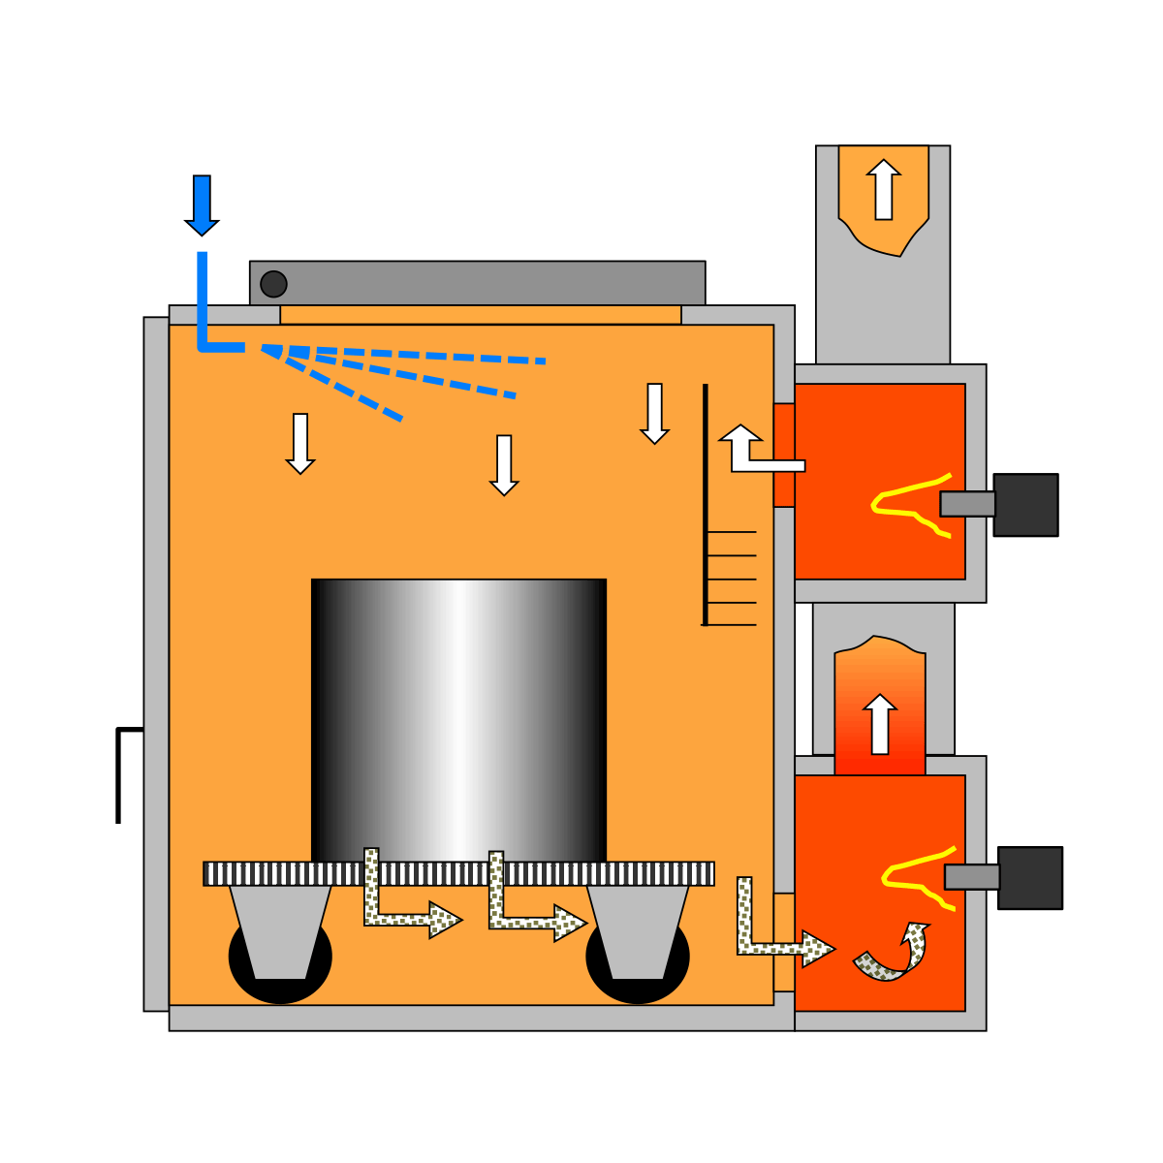
Functional principle of thermal cleaning in a MAXICLEAN system from SCHWING Technologies
Photo credit: SCHWING Technologies
Download: https://drive.google.com/file/d/1tQnKudmOR12CaW6dVCJr_gshXrhyxLoz/view?usp=sharing

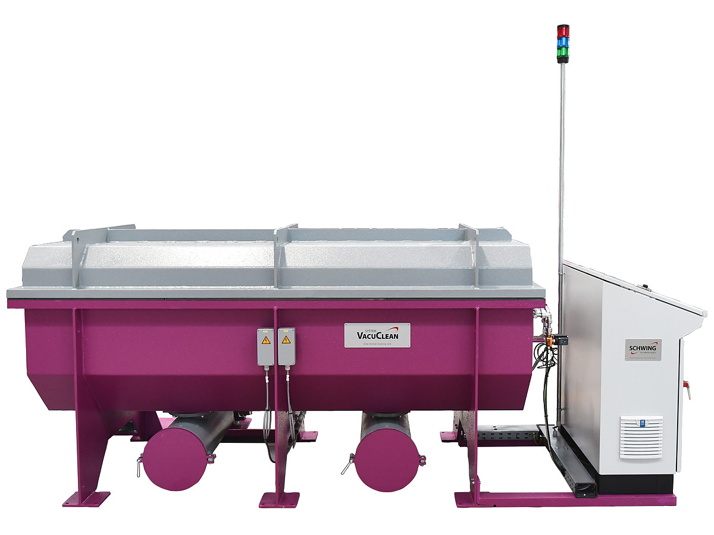
The VACUCLEAN thermal vacuum pyrolysis system from SCHWING Technologies works gently and cleans fully automatically
Photo credit: SCHWING Technologies
Download: https://drive.google.com/file/d/1AaC9o09h8MsP4Yq4fP3KZSBjGSiqbZeF/view?usp=sharing

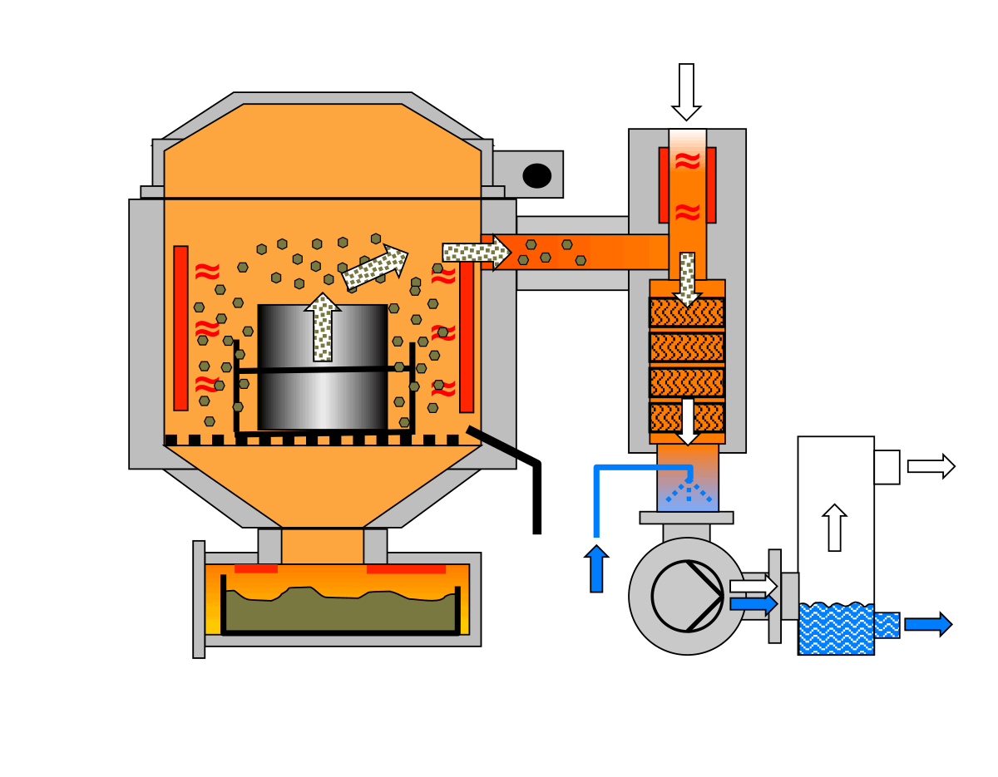

Functional principle of thermal cleaning in a VACUCLEAN system from SCHWING Technologies
Photo credit: SCHWING Technologies
Download: https://drive.google.com/file/d/1_PXi5ezpigwXeI59TwA_m7uP-sW4vlhY/view?usp=sharing
SCHWING Technologies
SCHWING Technologies has been operating for 50 years and is the worldwide technological leader for high-temperature systems for thermal cleaning, thermo-chemical finishing and heat treatment of metal parts and tools. The owner-managed company designs, manufactures, and operates systems at its headquarters in Neukirchen-Vluyn in Germany's Lower Rhine region. Built upon the achievements of German engineering, the medium-sized business is globally the best-known specialist in the removal of plastics. Among SCHWING’s approximate 2,500 international clients are companies from the plastics and fiber industries, as well as from the chemicals and automobile sectors. For every cleaning need, the company with its approximately 80 employees offers the most economically, ecologically and qualitatively best technology and cleaning solution. SCHWING is also a reliable service partner for contract cleaning by processing more than 250,000 tools and parts each year to the highest environmental and qualitative standards. So far, there has not been a single component that we have not been able to free from polymers and inorganic contaminants, confirm the three managing directors Ewald Schwing, Thomas Schwing and Alfred Schillert. Founded in 1969, the company celebrates its 50th anniversary in 2019 and opened SCHWING Technologies North America Inc., a new sales company in the USA, this year.

Press contact:
Nicola Leffelsend
SCHWING Technologies GmbH
Oderstraße 7
47506 Neukirchen-Vluyn
Germany
T +49 2845 930 146
redaktion@schwing-tech.com
www.schwing-technologies.com

