Press release

Neukirchen-Vluyn (Germany), 18 May 2021

First aid for overmolded hot runner components
German Formex Plastik GmbH relies on the fast and thorough cleaning of its hot runner components with the aid of thermal pyrolysis
What is to be done when hot runner systems overmold, stick and clog with older hot runners? When the material fails? When components break? To safeguard the production process and increase tool life, fast help is needed here. Especially for cleaning the hot runner manifolds used, Schwing Technologies offers reliable methods for fast and residue-free plastic removal. Instead of conventional methods using cleaning granules, torch flames or compressed air, the company cleans with the help of state-of-the-art thermal pyrolysis technology. This also applies to large hot runners with complicated geometries and angled channels. Adhering plastics are removed in a single operation - without leaving any residue, even if hot runners are heavily overmolded.

Formex Plastik GmbH - a practical example of perfect hot runner cleaning
The example of contaminated hot runners at Formex Plastik GmbH shows how Schwing cleans overmolded hot runners in particular. The company, based in the city of Kevelaer in the German Lower Rhine region, manufactures reusable plastic parts. These include folding and collapsible boxes, load carriers, housings, brooms or many other parts produced by means of plastic injection molding. With a wide range of machines, Formex produces micro-precision parts weighing 0.0005 kg as well as plastic transport pallets weighing 6 kg. "Our injection molding machines process several tons of engineering plastics, polyolefins as well as their recyclates every day," explains Torsten Kersting, head of mold making and design at Formex. Around 50 hot runners and manifolds are used for this purpose. These are overmolded due to material fatigue and broken components. They have to be cleaned as quickly as possible and freed of polypropylene so that they can be quickly returned to the production process.

Fast reavailability of overmolded hot runner systems
Formex has these hot runner components thermally cleaned by Schwing around three to four times a year. "Mostly unplanned as a rush job and always when hot runners are overmolded," says Kersting. In disassembled condition, the company has them transported by Schwing's logistics service to Neukirchen-Vluyn, about a 30-minute drive away. Here, several large pyrolysis plants, called MAXICLEAN systems, are available for plastic removal. After four to eight hours and within one operation, hot runner components are clean again without residue. Automatic process control ensures short cleaning times. The environmentally friendly cleaning process takes place in an externally gas-heated cleaning chamber with special hot air guidance. It ensures that the temperature is optimally distributed. Inorganic residues are removed in a coordinated post-treatment process. Any carbonization gases above 800 degrees Celsius are completely burned off and discharged via a stack. Afterwards, the hot runner components are ready for return transport and for re-molding by experienced moldmakers from Formex.

Thermal cleaning protects employees and the environment
Until 2019, overmolded systems at Formex were cleaned conventionally with hot air guns and torches. "This manual form of cleaning was very stressful for our team and our environment. Two years ago, we then decided to use Schwing's thermal cleaning service," explains Kersting, emphasizing, "The main focus was on protecting the health of our employees." In addition, the cleaning result of the manual process had not been one hundred percent satisfactory. The only advantage of this manual procedure, he says, was that it saved a large proportion of the electrical hot runner components. "Schwing's thermal cleaning, however, is faster and more thorough. It justifies the additional costs for the replacement of individual heating and thermocouples as well as cables," Kersting knows and emphasizes in conclusion: "Schwing's thermal technology scores with the reliable cleaning of all hot runner outer areas, but above all with the effective cleaning of the inner channels as well as the fast reavailability of the overmolded systems."

Keywords: hot runner cleaning, thermal pyrolysis, MAXICLEAN

Schwing sells its green cleaning systems worldwide and maintains a 24/7 cleaning and delivery service at its Lower Rhine site in Neukirchen-Vluyn. Further information on thermal pyrolysis technology (MAXICLEAN): https://www.thermal-cleaning.com/en/cleaning-systems-and-accessories/pyrolysis-furnaces.html?gclid=EAIaIQobChMI9-TmtvPh5AIVgoRwCh0YzQqjEAAYASAAEgK-LPD_BwE

About Schwing Technologies
Schwing Technologies has been operating for over 50 years and is the worldwide technological leader for high-temperature systems for thermal cleaning, thermo-chemical finishing and heat treatment of metal parts and tools. Managing directors are Ewald Schwing, Thomas Schwing and Alfred Schillert. The owner-managed company designs, manufactures, and operates systems at its headquarters in Neukirchen-Vluyn in Germany's Lower Rhine region. Built upon the achievements of German engineering, the medium-sized business is one of the world's best-known specialists in the removal of plastics. Among Schwing’s approximately 3,000 international clients are companies from the plastics and fiber industries, as well as from the chemicals and automobile sectors. For every cleaning need, the company with its approximately 100 employees offers the most economically, ecologically and qualitatively best technology and cleaning solution. Schwing is also a reliable service partner for contract cleaning by processing more than 250,000 tools and parts each year to the highest environmental and qualitative standards. Founded in 1969, the company celebrates its 50th anniversary in 2019 and opened Schwing Technologies North America Inc., a new sales company in the USA, in that year.

Press contact
Nicola Leffelsend
SCHWING Technologies GmbH
Oderstraße 7
47506 Neukirchen-Vluyn, Germany
M +49 173 9774780
T +49 2845 930 146
redaktion@schwing-tech.com
www.schwing-technologies.com

Facebook: schwing.technologies
Twitter: SCHWING_TECH
LinkedIn: SCHWING Technologies GmbH
YouTube: ThermalCleaning

Photos
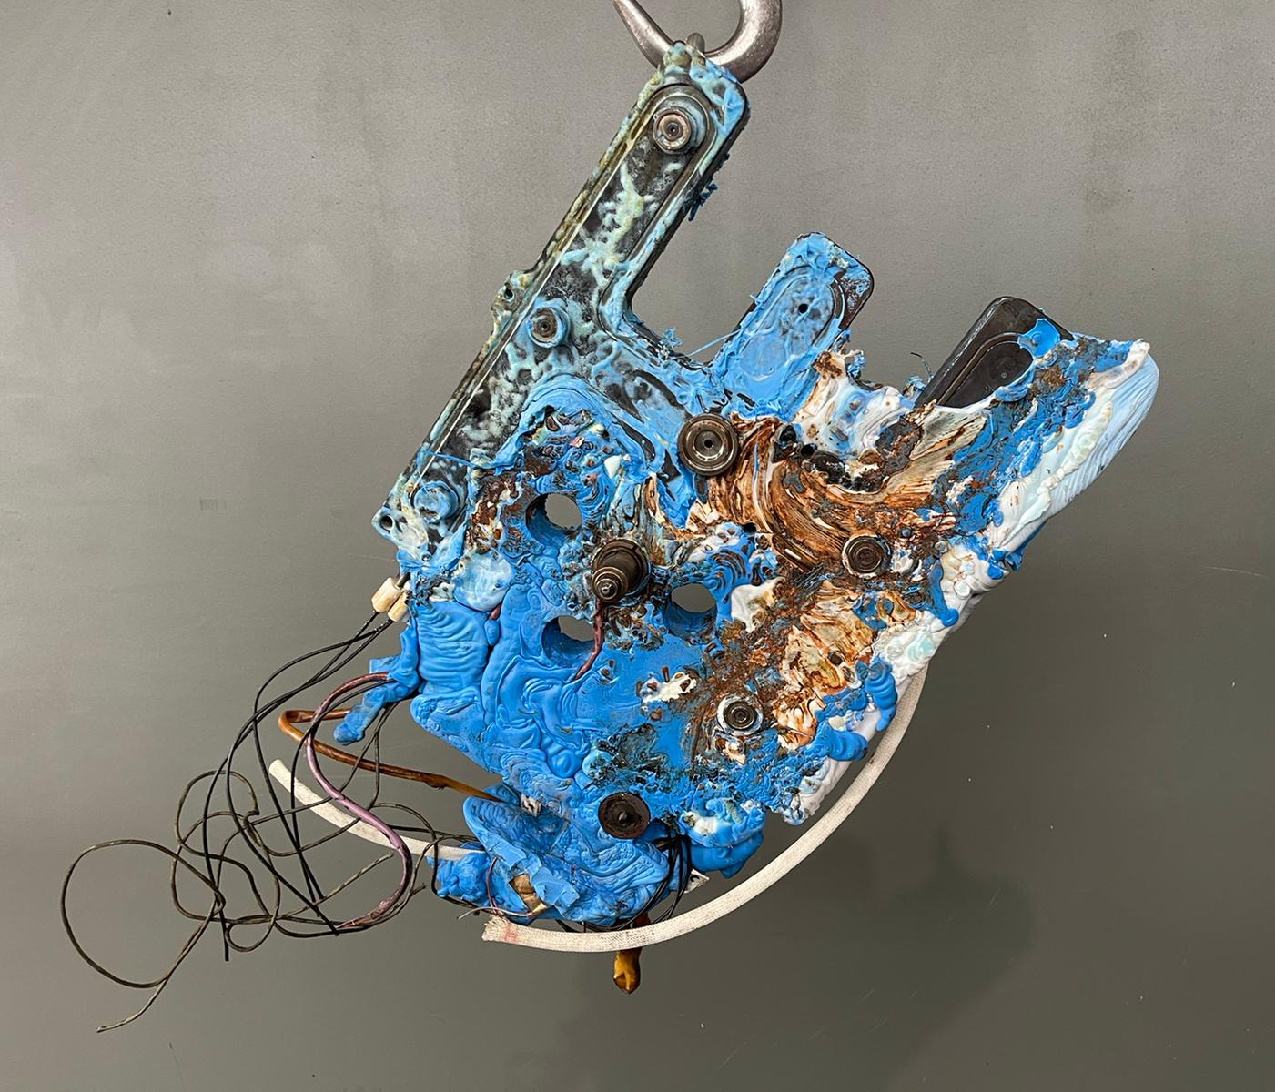 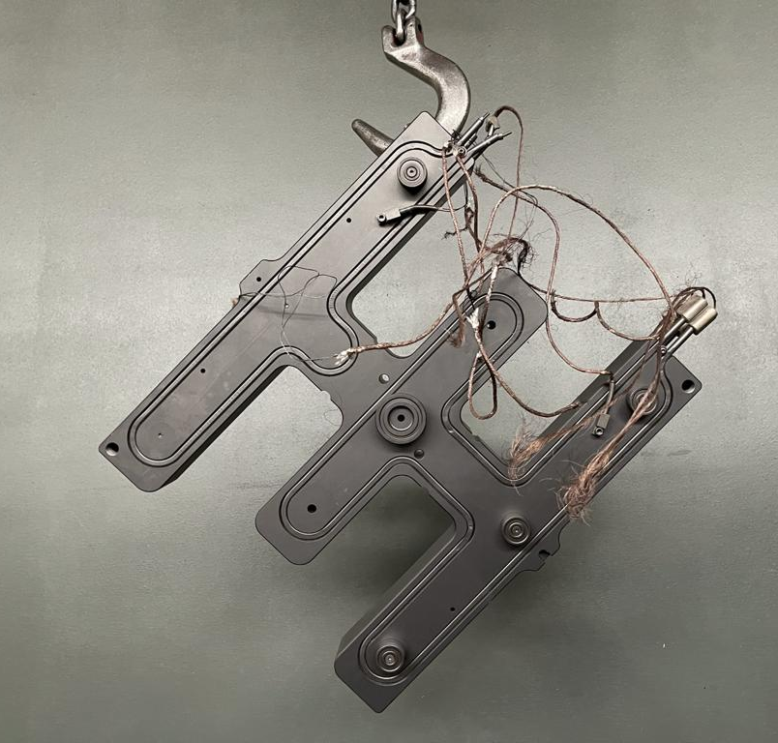
Schwing Technologies ensures the safe thermal removal of plastic residues from hot runner systems of Formex Plastik GmbH - here before and after cleaning
Photo credits: SCHWING Technologies
Download (before): https://drive.google.com/file/d/1jetzwPnHifdC2bpC7z80HFfvPT79TSXR/view?usp=sharing
Download (after): https://drive.google.com/file/d/1lqhggi-pdLLdBg1QwKg3eS3XVG5UxR0k/view?usp=sharing
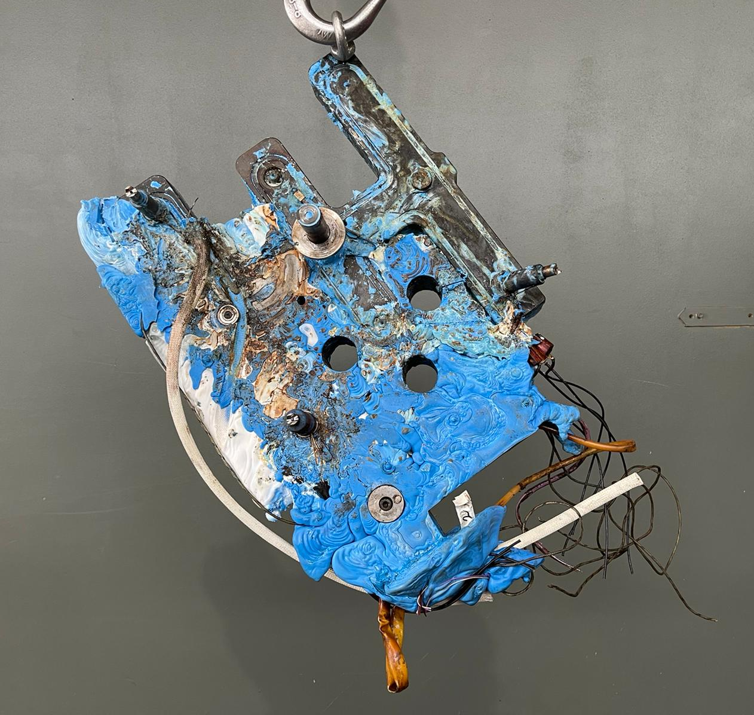 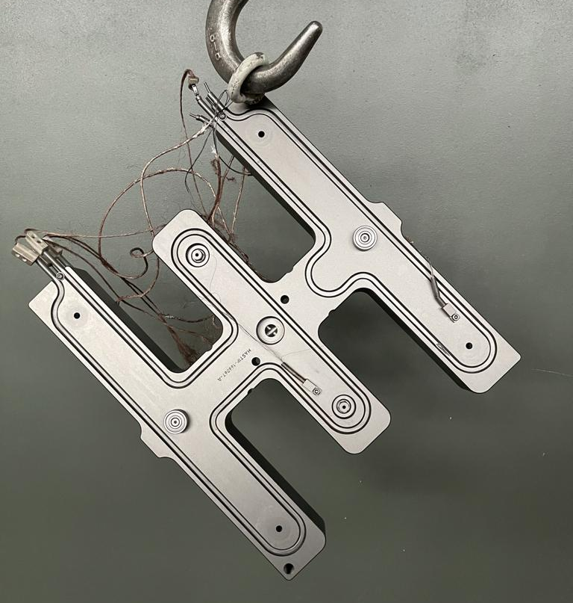
Hot runner system of Formex Plastik GmbH with polypropylene residues before and after thermal cleaning
Photo credit: SCHWING Technologies
Download (before): https://drive.google.com/file/d/1J9P2CY_KHvFdIPFnudf8pUG9elhk2yBn/view?usp=sharing
Download (after): https://drive.google.com/file/d/1HlKBqBtQaefk0peBW6S57h2TG6ZfITcS/view?usp=sharing
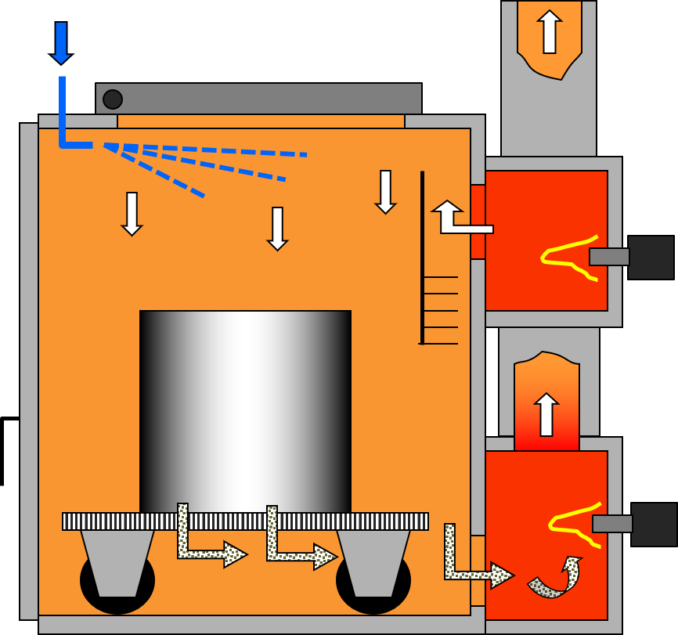
Functional principle of Schwing Technologies' thermal pyrolysis technology
Photo credit: SCHWING Technologies
Download: https://drive.google.com/file/d/1L7sAU6eOmK-mwh1EThWr6hFmc25ty0Fa/view?usp=sharing

